Dear Homeowner,
We are pleased to introduce ourselves as the new financial manager for St. James Pointe HOA.
Community Financials will work on behalf of your association, handling the dues and assessments, billing and collections, invoice payment, and other financial and administrative services as outlined in the attached.
Community Financials works with over 35,000 homeowners in over 385 communities nationwide. Since 2018 we've been helping associations get better accounting information, with easy-to-use systems, and industry-leading service.
This letter contains important instructions for registering your unit in our online owner’s portal and setting up payments to safely and securely ensure your dues and assessments are paid timely.
REGISTERING ON THE SMARTWEBS PORTAL FOR YOUR COMMUNITY

Our service includes access to an easy-to-use online owner’s portal where you can go to:
- Update and maintain your contact information.
- View and print your account ledger and make payments.
- Send and track inquiries, concerns and architectural review requests to us and/or the board.
- View answers to Frequently Asked Questions (FAQs) and more.
You have two methods to register on our portal. First, check your email for a WELCOME invitation, which looks like the image below. Click on the bright orange link button in that email to create your account.
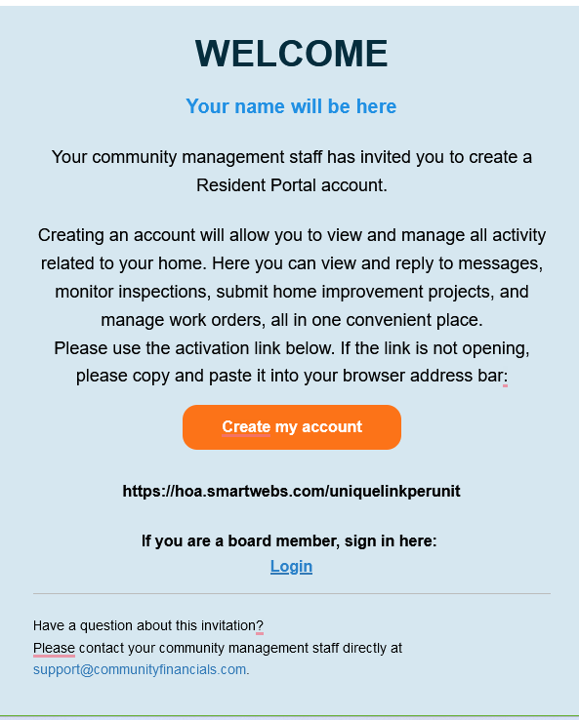

If you didn’t receive or cannot find an email, first check your junk or spam folder and look for an email from support@communityfinancials.com. If you still cannot find the WELCOME email, you can register using the following instructions below:

- Go to SMARTWEBS (https://office.smartwebs.com).
- Click “Residents: click here to set up your account”.
- At the “Verification of Ownership” screen enter your Association Name St. James Pointe HOA and zip code of 73179 and then “search”.
- Click on your association name.
- Click ‘find your unit’ and enter your last name and unit address.
- Check for your confirmation email and click the link in the email to create your account.
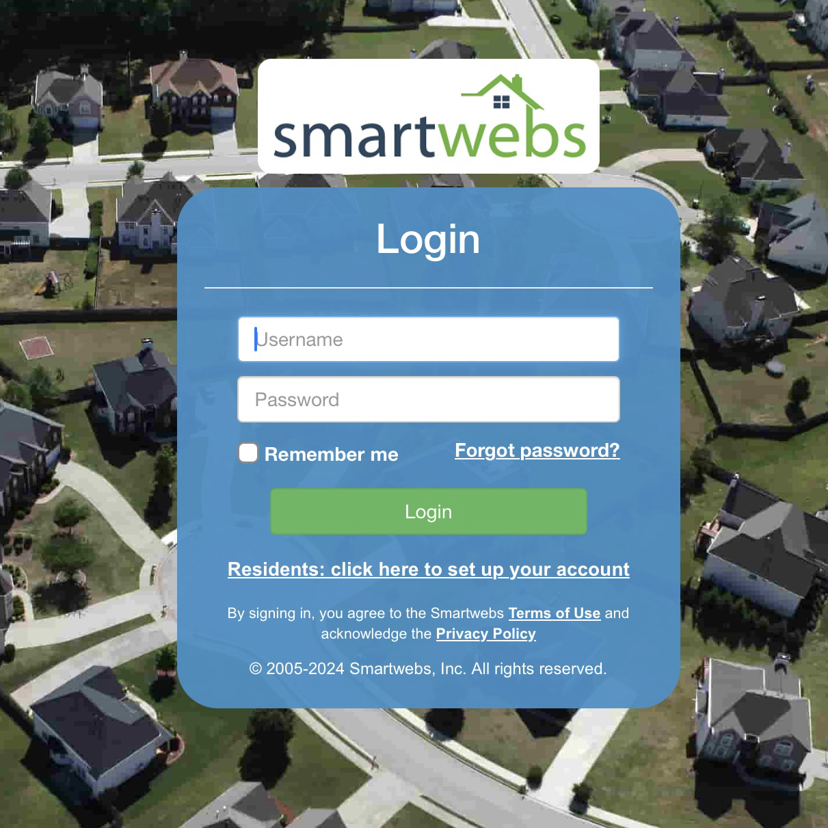
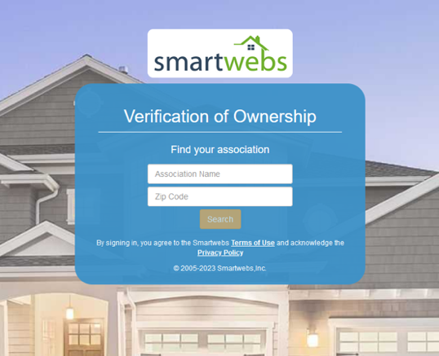

SETTING UP ONLINE PAYMENTS IN THE PORTAL

Once registered in the portal click the blue “Pay” button or “Auto Pay” to setup recurring payments and you’ll be directed to our payment partner and access our online payment service. Here you can choose an online payment option from the following choices:
- You may set up a one-time payment or recurring payment at NO COST by securely entering your bank account and routing number (via ACH)
- You may also pay your assessment using Visa, MasterCard, AMEX or Discover, however such transactions will incur a 3.5% convenience fee for cards.

We encourage you to set up recurring payments as these will ensure your dues and assessments are paid timely and help avoid late fees.

OTHER PAYMENT OPTIONS

Residents may also pay by check, email, or through their personal bank’s online bill payment system, however, these options could result in delays in receiving or processing your payments and also will require residents to monitor closely for changes in the amount billed as a result of dues changes or other fees.

Paying by Check or Money Order

You may pay by check or money order by making either instrument payable St. James Pointe HOA and mailing to the following address:

St. James Pointe HOA
PO Box 174386
Denver, CO 80217-4386

Be sure to include your new ten-digit account number (included in the top right-hand corner of your statement) on your check. To help the deposit of your check to be faster, please send the bottom portion of your statement with your check if you have a printer.

Using your Personal Bank’s Online Bill Pay System:
Because most banks’ online bill payment systems print and mail a physical check, please allow for up to 10 calendar days for check printing and delivery when scheduling your payments in order to avoid late fees.If you are currently using your bank’s bill payment service, please DELETE the existing payment plan and set up an entirely new payment with your new unique account number and remittance P.O. Box address above. DO NOT just edit the payment by changing the address and account number. That could cause your payment to be misrouted (lost) or returned to you.
SmartWebs is our cloud-based software that has security measures from hackers who predominately operate outside of the US. For owners that live outside of the US they need to use a VPN that has a US IP address. Here is a link to one such service that allows owners to choose the country of their IP address and is a good value: Surfshark VPN
Please note if you have a balance due or credit we will reflect that soon in SmartWebs and you will see this on your next statement.
Should you require assistance registering on our portal or have questions about your account or how to pay your bill, please email support@communityfinancials.com or call (833) 266-3646 option 1. We also have a dedicated contact for resale assistance at resale@communityfinancials.com or call (833) 266-3646 option 3.
Please note our customer service hours are 8AM – 8PM CST Monday – Friday. We also have Spanish assistance available at extension 728.
We look forward to working with you and your community.
Sincerely,
Community Financials

